To figure out the best colour mask I implemented this code:

locateDot():

This gave me an idea of what colour combinations make the mask work better, so I played around with the values until I got what I wanted:

Gave me:

Through trial and error and a bit of common sense, I narrowed it down to these colours:

I noticed no difference at all in any of the green values, so I’m picking the middle one, giving me the mask of:

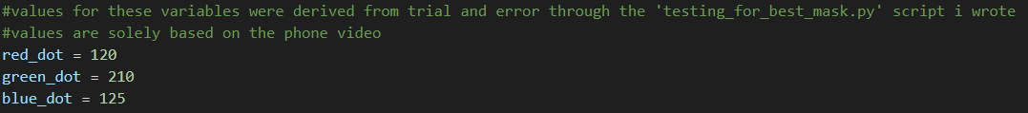

I worry that this may only work on the images I have selected, so I have thought up a way to get a definitive answer for which colour parameters I’m going to use so I will want to run another experiment now I have an idea of what parameters I want to use.

It’s at this point I realise ive not been using the correct colour space to begin with so I am completely redesigning my functions and experiments.

Eventually, after a lot of trial and error I found these values that worked for CMY:

Giving us:

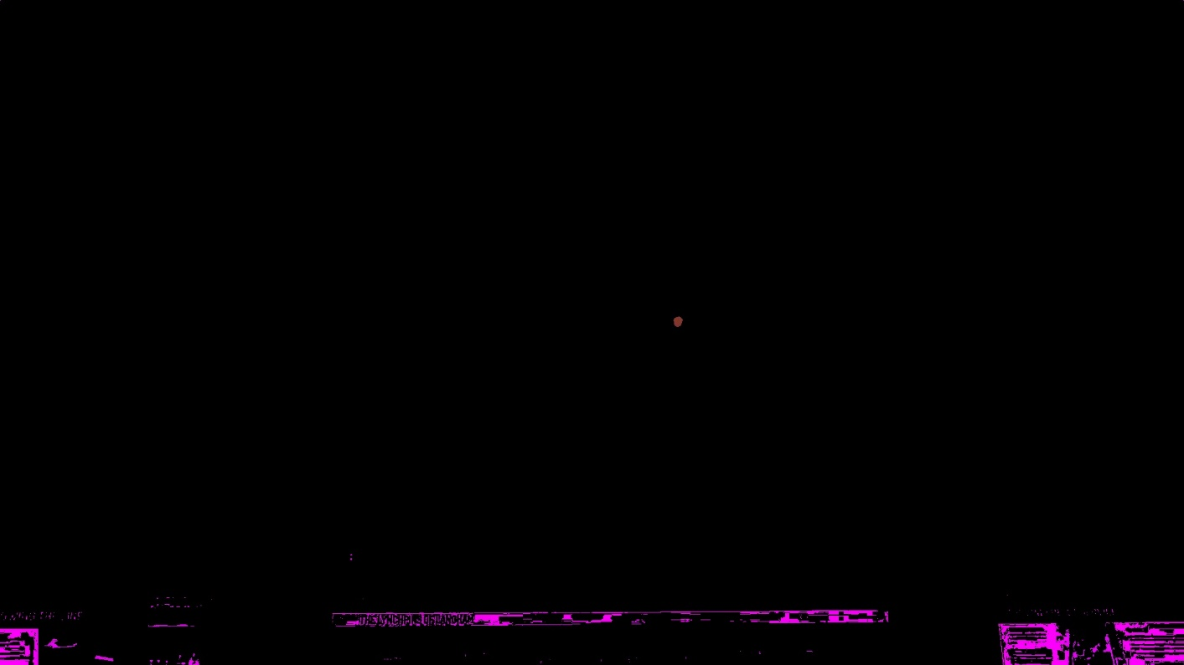

For two different images

And these values for RGB:

Giving us:

and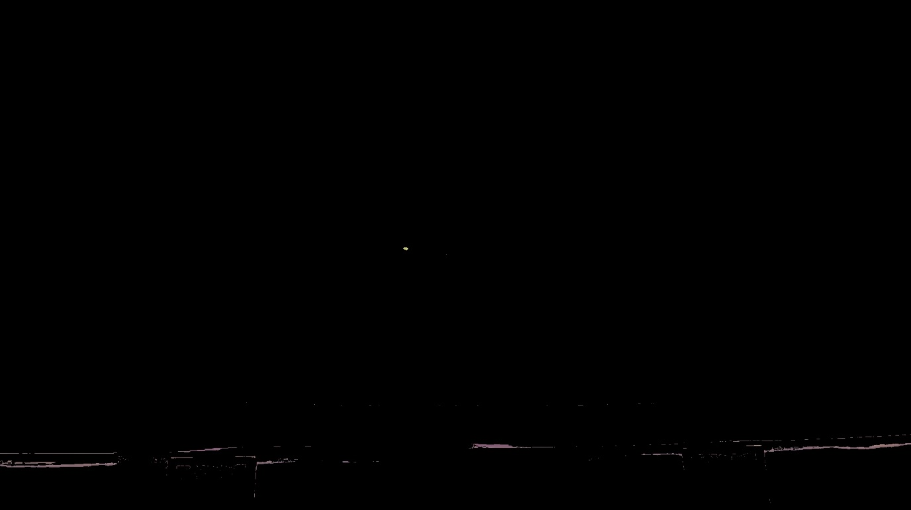

for two different images.